Royalty Beauty Pageant
Saturday July 15th, 2017

Contestant Name: _________________________________________
Category: ______________ Gender: _________ Date Of Birth: ______________
Age:_______ Address:_____________________________ City:_______________
Zip Code:________ Email:____________________ Phone Number:____________
Registration/Check-In @ 10:45 – 11:30! Pageant begins at 12:00am. Join us on fb @ Royalty Pageantry
check all that applies:
Pageant $50 paid by July 4th
Pageant $40 paid by June 1st
$_______ Total Due

Pay by :
___ money order payable to Satawana Redding.
___ Cash at door or pay in advance.
___ Online payment made by PayPal @mzredding1@aol.com.

Items Enclosed:
__ Money Order/Cash
__ Signed Application
__ Personal Bio Page
__ Photogenic Photo
Refer a Contestant
___ $25 off Discount
*Contestant must have applied and paid already to receive discount!*
Girls
NB - 11 Months - Duchess
Age 1– 2 Little Princess
Age 3 –4 Princess
Age 5 – 6 Little Queen
Age 7- 9 Queens
Age 10 – 15 Little Goddess
Age 16 – 21 Goddess
Boys
0-23 months Dukes
2-4 Prince
5-12 Kings

I agree that all decisions are final. No Royal Beauty Pageant or affiliate will be responsible for any injuries that could occur nor be responsible for any lost, damaged, or stolen property during pageant activates. I understand that if the rules are broken, it will prevent me and my child from all future participation in Royalty beauty pageants. You agree to all the rules and terms of Royalty Beauty Pageant.
Signature of Guardian (or applicant that is over 18years of age)
____________________________________________________________
Name of Guardian (or contestant that is over 18 years of age)

Contestant Information:
- Location- North Hampton Town Hall 851 W. Bath road Cuyahoga Falls, OH 44223
- Date- Saturday July 15th, 2017.
- Pageant time – 12:00pm
- Registration Check-in : 10:45am-11:30am
- Pageant Fee: Receive a Ten Dollar ($10.00) off discount if paid by Thursday June 1st 2017 entry fee will be Forty Dollars ($40.00) for pageant. Fifty Dollars ($50.00) if paid after Thursday June 1st 2017. Final payment due Thursday July 1st 2017. Refer a contestant and enter the pageant for Twenty-Five Dollars ($25.00). References and application must be filled out with contestant’s payment prior to receiving your discount.
- Attire: Beauty as well as Independence Day/Fourth of July Theme. All natural pageant so no makeup, fake hair, fake eyelashes, no flippers or things of that nature. Contestants 12 and up can wear light makeup. Contestants not in compliance with these rules will have points deducted off their overall score.
- Judges: None of the judges will be family members or close friends to ANY of the Royalty Pageant Contestants. All decisions are final! Royalty Beauty Pageant members do not score contestants. However we will have Directors Choice Awards (DCA).
- Judging: Contestants are scored based on appearance, physical beauty, stage present, attitude/personality, and costume.
- Prizes for beauty pageant: Main Pageant contestant winners will receive 1st, 2nd, and 3rd place trophies. Side Category award winners will receive medallions.
- Admission: The fee for all spectators will be $1.00. All Contestants will not have to pay admission fee.
- Refer a Contestant: If you refer a contestant, we will give you 50% off the original entry fee the price will be Twenty-Five Dollars ($25.00). To receive discount the referred contestant must have filled out application and already paid entry fee.
- Applications: Please make sure all contestants and/or parent/guardian fill out all information on the application. Be sure to include money order or cash with application unless you are paying online via PayPal. Also be sure to fill out contestants Personal bio and attach a photogenic picture when turning in the application.
- Questions: Any questions or concerns please email the Pageant Directors at Mzredding1@aol.com or Mzvonhowell@gmail.com.

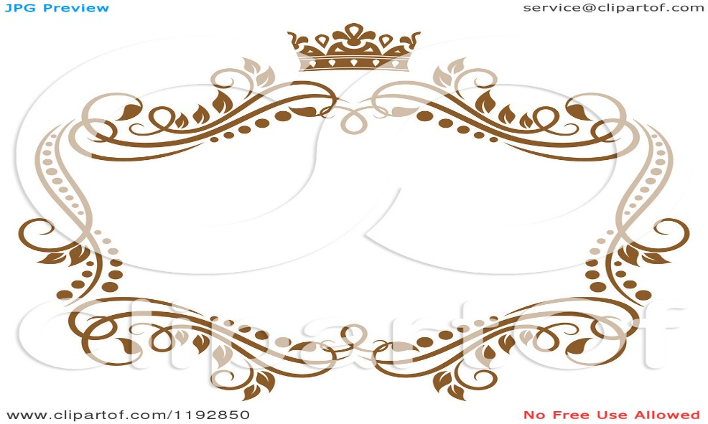
Royalty Beauty Pageant

Royalty Beauty Pageant Personal Biography Sheet

Please print clearly and keep all information on the front of the bio sheet.
First Name _______________ Last Name _________________ Boy Girl
Pronounced _____________________________________________________
Hometown_______________________ School_______________________ Age____

The Following information will be read when the contestant is on stage.

Complete for younger contestants(ages NB – 7 years old)
Brothers/sisters ________________________________________________________________
Favorite Toy or Game ____________________________________________________________
Child’s Biggest Achievement so far _________________________________________________
Favorite Singer/Song ____________________________________________________________
Favorite Cartoon _______________________________________________________________

Older contestant questions (ages 8 – 21 years old)
Briefly describe some things you are proud of: __________________________________________________________________________________________________________________________________________________________________________________________________________________________________________

What awards or accomplishments have you received in the past 4 years? __________________________________________________________________________________________________________________________________________________________________________________________________________________________________________

What is your favorite quote? __________________________________________________________________________________________________________________________________________________________________________________________________________________________________________

What are your future goals? __________________________________________________________________________________________________________________________________________________________________________________________________________________________________________

Scoring Sheet

Name:_____________________________________ Age:_______

Photogenic- 40 pts (Rate 1-10)
Captivating | 1/10
Clear Image of Face | 1/10
Shows Personality | 1/10
Natural Beauty | 1/10

Beauty: 100 pts (Rate 1-20)
Natural Beauty | 1/20
Stage Presence | 1/20
Personality | 1/20
Confidence | 1/20
Overall impression | 1/20

Theme Wear: 100 pts (Rate 1-20)
Originality/Creativity | 1/20
General Appearance | 1/20
Outfit/dress | 1/20
Stage Presence | 1/20
Overall impression | 1/20

Side Awards: 40 pts (Rate 1-10)
Best hair | 1/10
Prettiest eyes | 1/10
Best smile | 1/10
Charisma | 1/10

